1. User Defined Variables element to provide the test bed details.

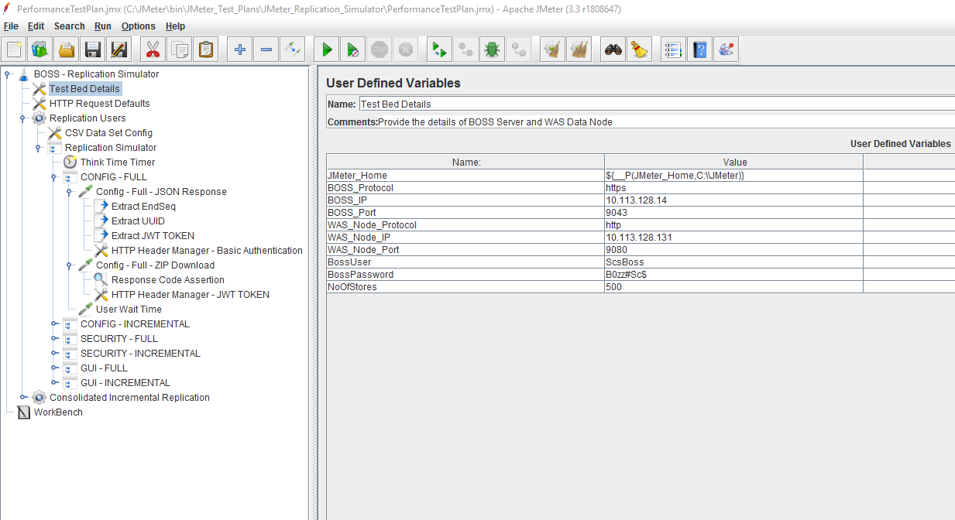

1. Thread Group which defines the number of threads and test duration. These values are externalized using JMeter variables. The Number of Threads and Duration values are passed interactively through a batch script.

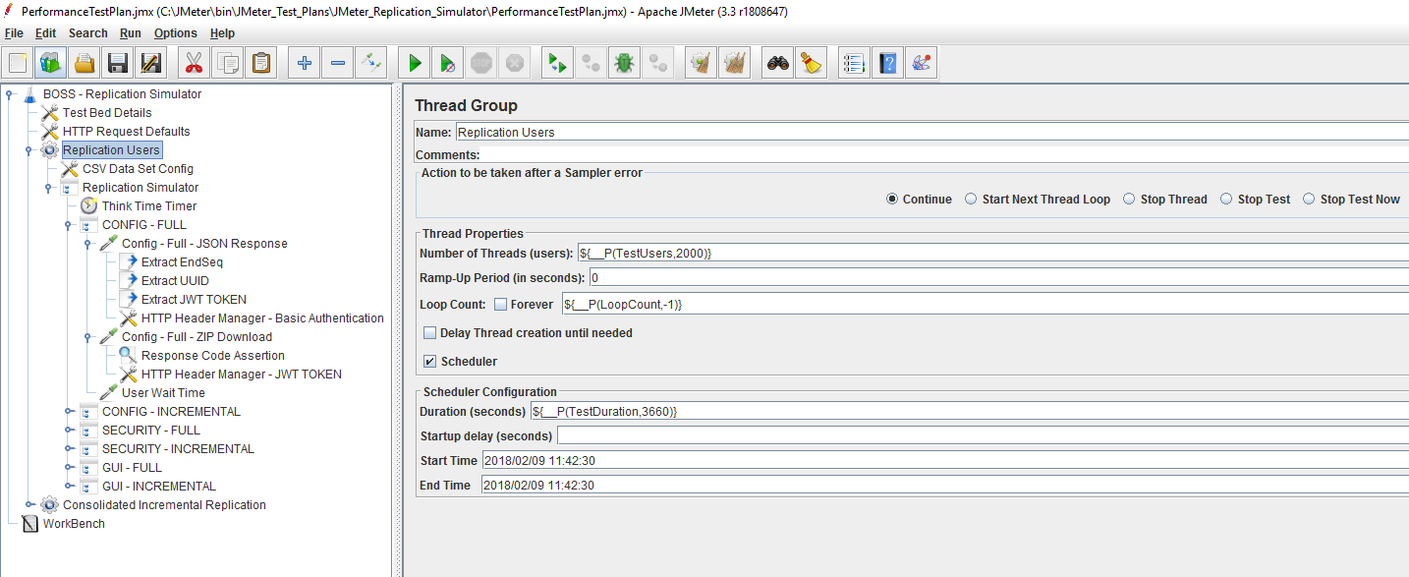

1. Throughput Controllers are used to control the load for each type of request.

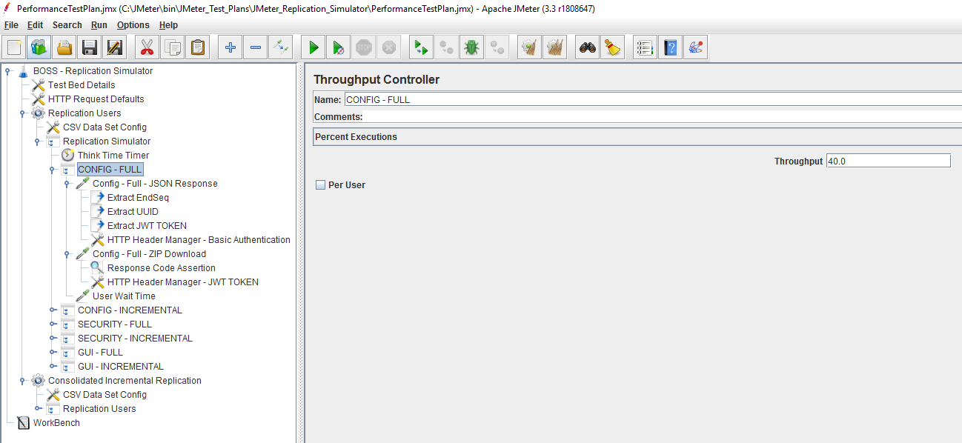

1. HTTP Request Sampler to send the REST API request to WAS Nodes.

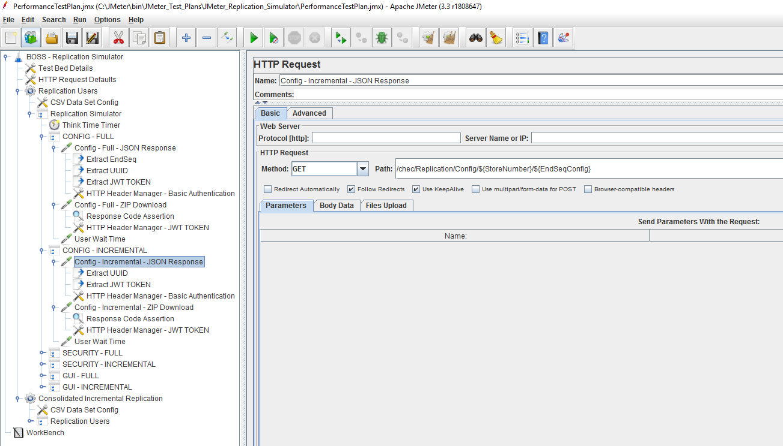

1. HTTP Request Sampler is used to process the zip files.

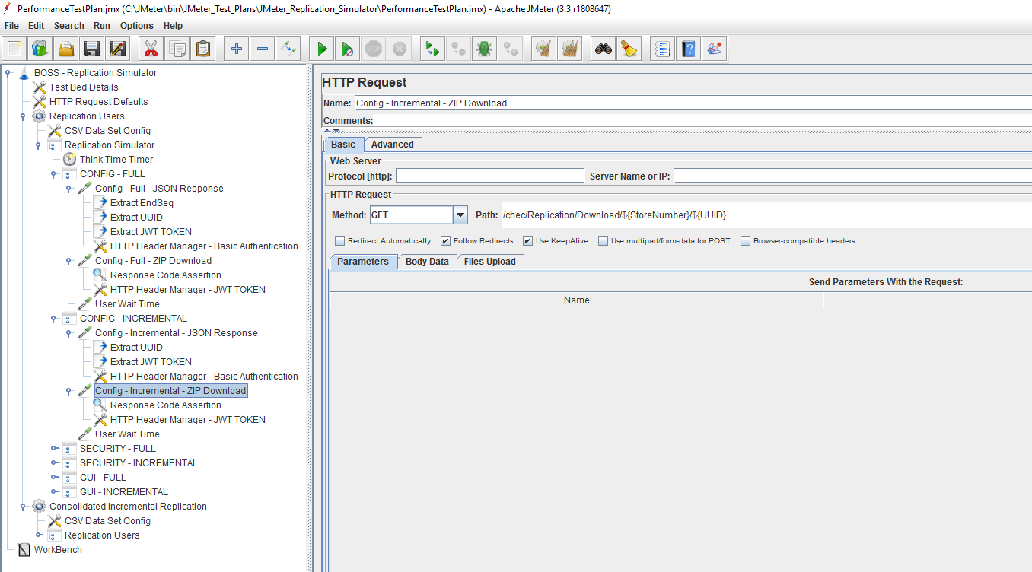

1. HTTP Header Manager is used to pass the BasicAuthentication.

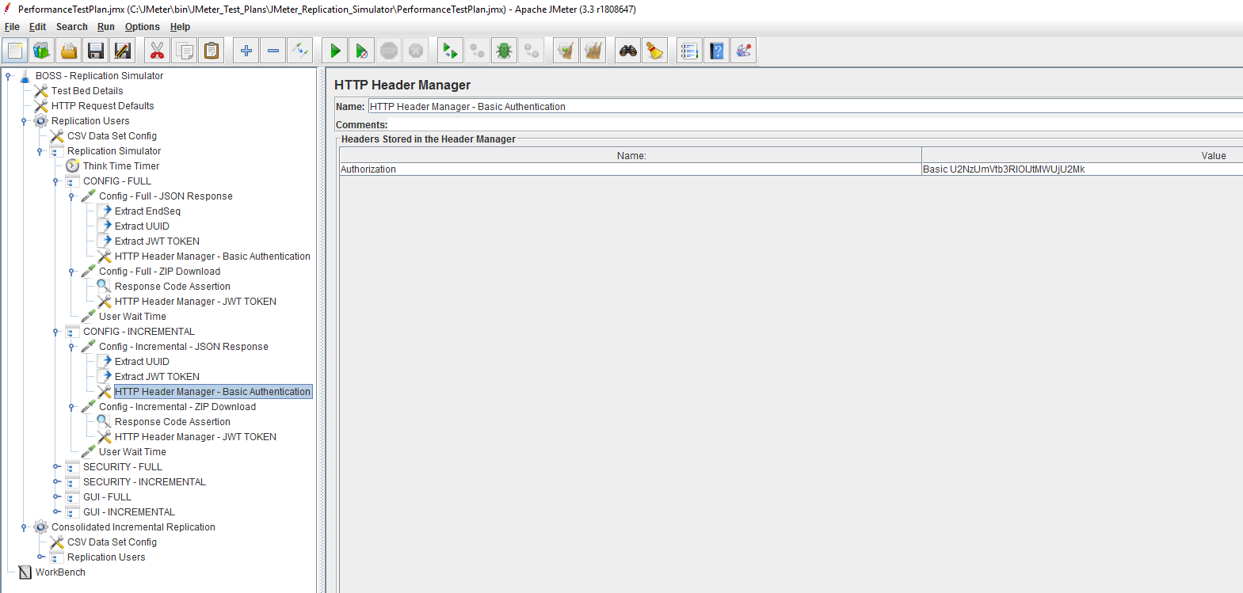

1. HTTP Header Manager is used to pass the JWT Token.

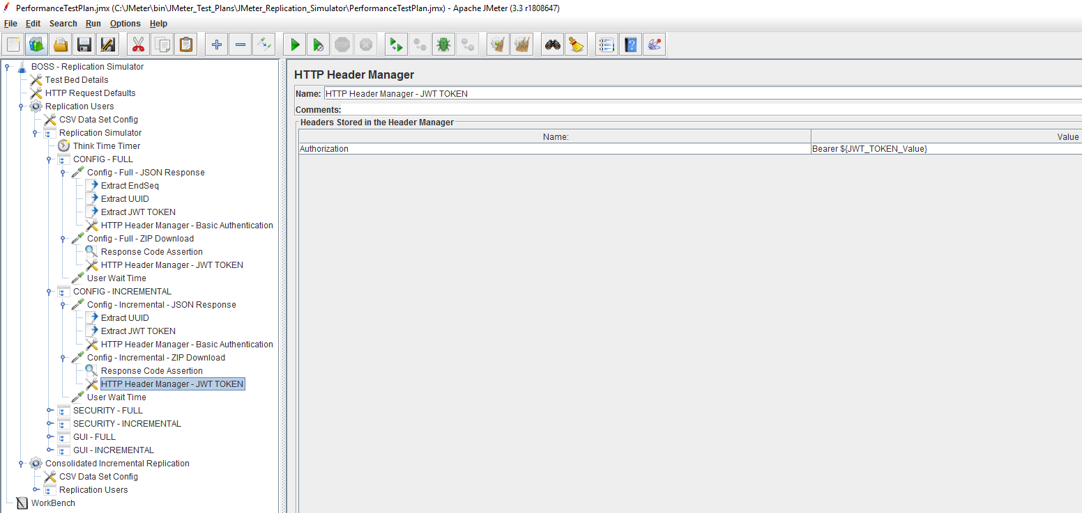

1. Response Assertion is used to verify the responses from server

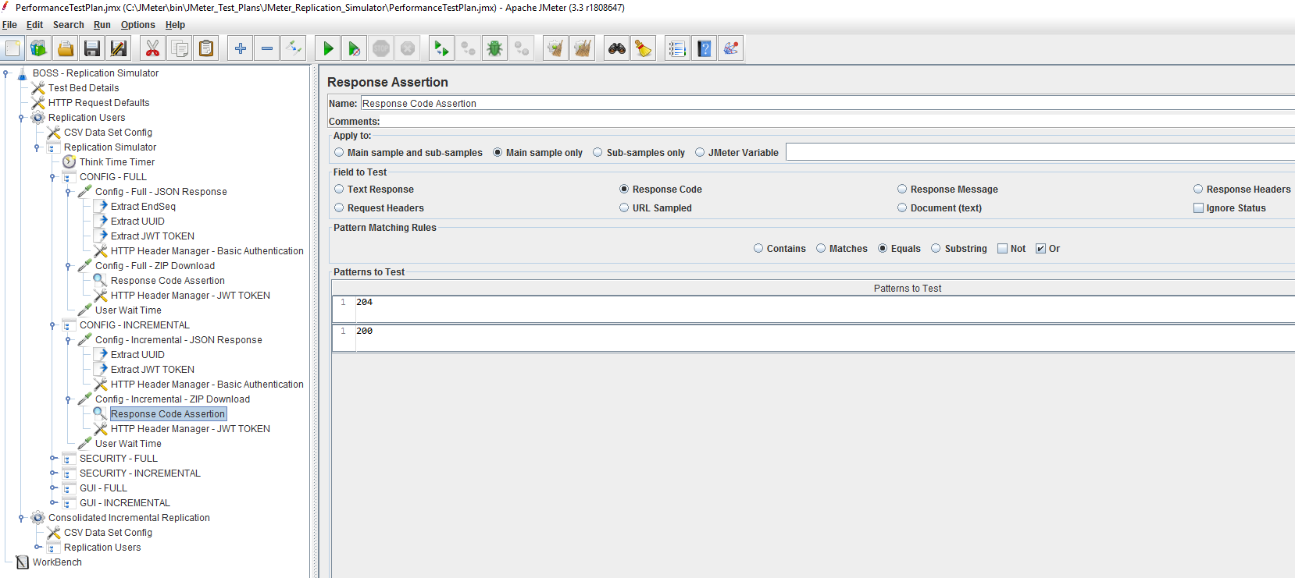

1. Batch file created to run the JMeter Replication Simulator in Non-GUI mode.

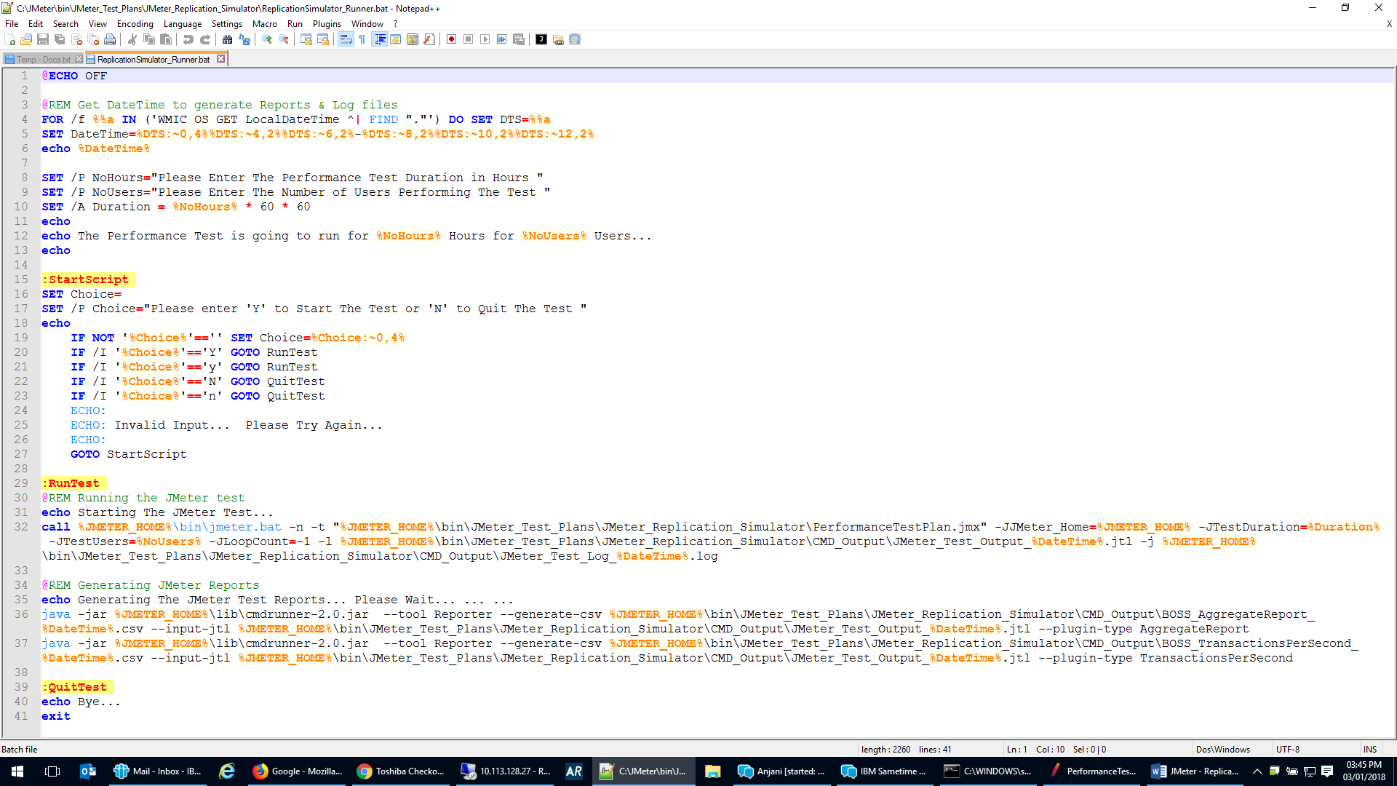

1. Run the batch file in Administrator mode to initiate the test. Pass the test duration in hours and number of users in the command line window.